Types of Modems
# Source: Chatgpt (GPT‑5 Mini) at [12/18/2025]
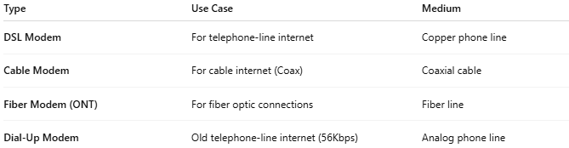

Type | Use Case | Medium
DSL Modem | For telephone-line internet | Copper phone line
Cable Modem | For cable internet (Coax) | Coaxial cable
Fiber Modem (ONT) | For fiber optic connections | Fiber line
Dial-Up Modem | Old telephone-line internet (56Kbps) | Analog phone line

